PRACTICAL 6

/*Program that shows a Person can be a Customer or an Employee. (Hierarchical Inheritance) */

#include<iostream.h>

#include<conio.h>

#include<stdio.h>

class Person

{

private:

int Pcode;

char Pname[25];

char Paddress[30];

public:

void Person_data();

void Person_display();

};

class Employee: public Person

{

double Salary;

public:

void Input_salary();

void Print_salary();

};

class Customer : public Person

{

double Amount;

public:

void Read_cust();

void Show_cust();

};

void Person::Person_data()

{

cout<<"Enter code:";

cin>>Pcode;

cout<<"Enter name:";

gets(Pname);

cout<<"Enter address:";

gets(Paddress);

}

void Person::Person_display()

{

cout<<"\nCode:"<<Pcode;

cout<<"\nName:"<<Pname;

cout<<"\nAddress:"<<Paddress;

}

void Employee::Input_salary()

{

cout<<"\nEnter information for employee:\n";

Person_data();

cout<<"Enter salary:";

cin>>Salary;

}

void Employee::Print_salary(void)

{

Person_display();

cout<<"\nSalary:"<<Salary;

}

void Customer::Read_cust(void)

{

cout<<"\nEnter information for customer:\n";

Person_data();

cout<<"Enter shopping amount:";

cin>>Amount;

}

void Customer::Show_cust(void)

{

Person_display();

cout<<"\nCustomer shopping amount:"<<Amount;

}

void main()

{

clrscr();

Employee Emp;

Customer Cust;

Emp.Input_salary();

Cust.Read_cust();

cout<<"\nHere is the employee information:\n";

for(int i=1; i<=32; i++)

cout<<"=";

Emp.Print_salary();

cout<<"\nHere is the customer information:\n";

for(i=1; i<=32; i++)

cout<<"=";

Cust.Show_cust();

}

OUTPUT 6

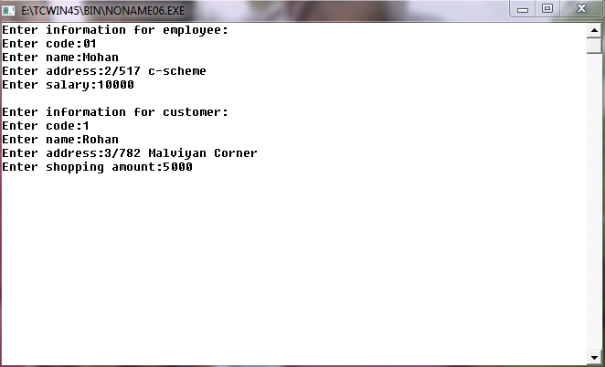

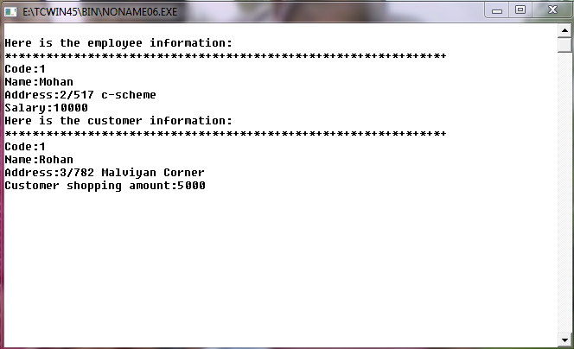

PRACTICAL 7

/* Program to search and delete data of employee*/

#include<iostream.h>

#include<fstream.h>

#include<stdio.h>

#include<stdlib.h>

struct emp

{

  int eno;

  char ename[20];

  float salary;

}emp;

void main()

{

  fstream s,t;

  int total=0, no,a, flag=1;

  int ch;

  char ans;

  a:

  s.open("Emp.dat", ios::in);

  cout<<" MENU :"<<endl;

  cout<<" Enter 1 to Search "<<endl;

  cout<<" Enter 2 to Delete "<<endl;

  cout<<" Enter 3 to Exit "<<endl;

  cout<<" Enter choice : ";

  cin>>ch;

  switch(ch)

  {

 case 1:

 {

  cout<<" Enter the number you want to search : ";

  cin>>no;

  s.read((char*)&emp,sizeof(emp));

  while(s)

  {

if(no==emp.eno)

{

cout<<" Employee no : "<<emp.eno<<endl;

cout<<" Employee name : ";

puts(emp.ename);

cout<<" Salary : "<<emp.salary;

}

s.read((char*)&emp, sizeof(emp));

  }

  s.close();

  break ;

}

case 2:

{

cout<<" Enter the number you want to delete : ";

cin>>no;

while(s)

{

  if(!s)

  exit(0);

  s.read((char*)&emp,sizeof(emp));

  if(emp.eno==no)

  {

  flag=1;

  }

  else

t.write((char*)&emp,sizeof(emp));

  }

  s.close();

  t.close();

  if(flag==1)

 cout<<" Record deleted !!. ";

  else

 cout<<" Record not found !!. ";

  fstream x, y;

  x.open("Temp.dat",ios::in);

  y.open("Emp.dat", ios::out);

  while(x)

  {

 if(!x)

  exit(0);

x.read((char*)&emp,sizeof(emp));

y.write((char*)&emp,sizeof(emp));

  }

  x.close();

  y.close();

  break;

}

  case 3:

  {

break;

  }

 }

 cout<<endl<<" Do you want to continue : ";

 cin>>ans;

 if(ans=='y')

  goto a;

 else

  exit(0);

}

OUTPUT 7

